**CONTENTS**

1. **INTRODUCTION**
   1. Introduction to Project
   2. Purpose of Project
2. **SYSTEM DESIGN**
   1. Hardware Requirements
   2. Software Requirements
   3. Flow diagram of Project
3. **RESULTS**
4. **INTRODUCTION**
   1. **Introduction to Project**

Designed a website named UNH FEST where students can check the events which are being held by the university only after they are registered. Already registered students can login with their credentials and check the events that are present. After logging in a student can register to an event by entering his student id and event name.

**Purpose of Project**

The basic view of this project is to optimize the search of events being held for the students as well as the guests who are willing to attend. It is just like a reminder website where when they login they can check the registered events and make their schedule to attend them.

1. **SYSTEM DESIGN**
   1. **Hardware Requirements**

Hardware requirements describe the basic version of hardware needed to run the

application. In case of high speed of execution, developer can use updated versions.

My personal PC requirements are being disclosed.

**Processor**: Inter(R) Core (TM) i5-7200U CPU @ 2.50 GHz 2.70GHz

**RAM**: 8GB

**Hard Disk Drive**: 2TB

* 1. **Software Requirements**

**Technology Used:** Java, MySQL, HTML, JSP, CSS

**Platform Used:** Eclipse Photon and MySQL Workbench

* 1. **Flow Diagram of Project**

The entire project is designed using the MVC Model-2 First Case Architecture. Here from JSP the Controller receives the message, checks the information and display it accordingly. The diagram of the MVC structure which I have considered is

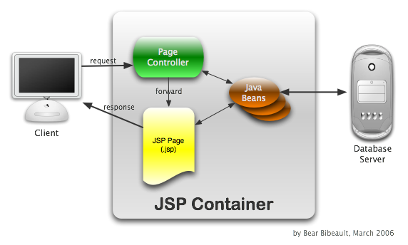

Entire flow of my project it explained with the names of my html and java files

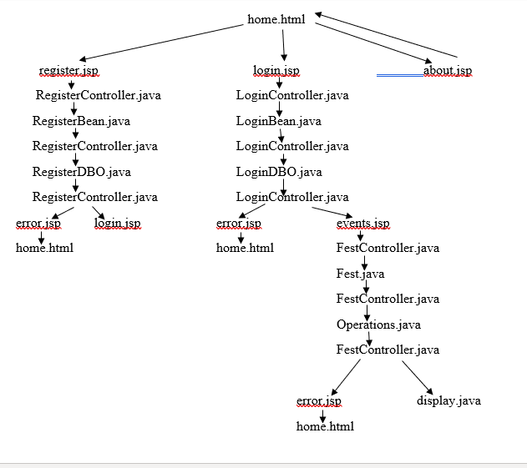

1. **RESULTS**
2. Database

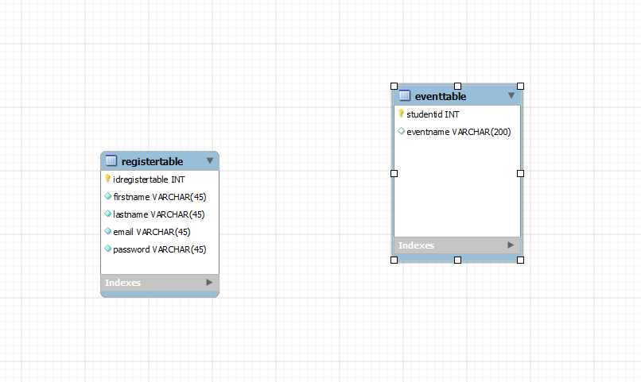

1. Index.html

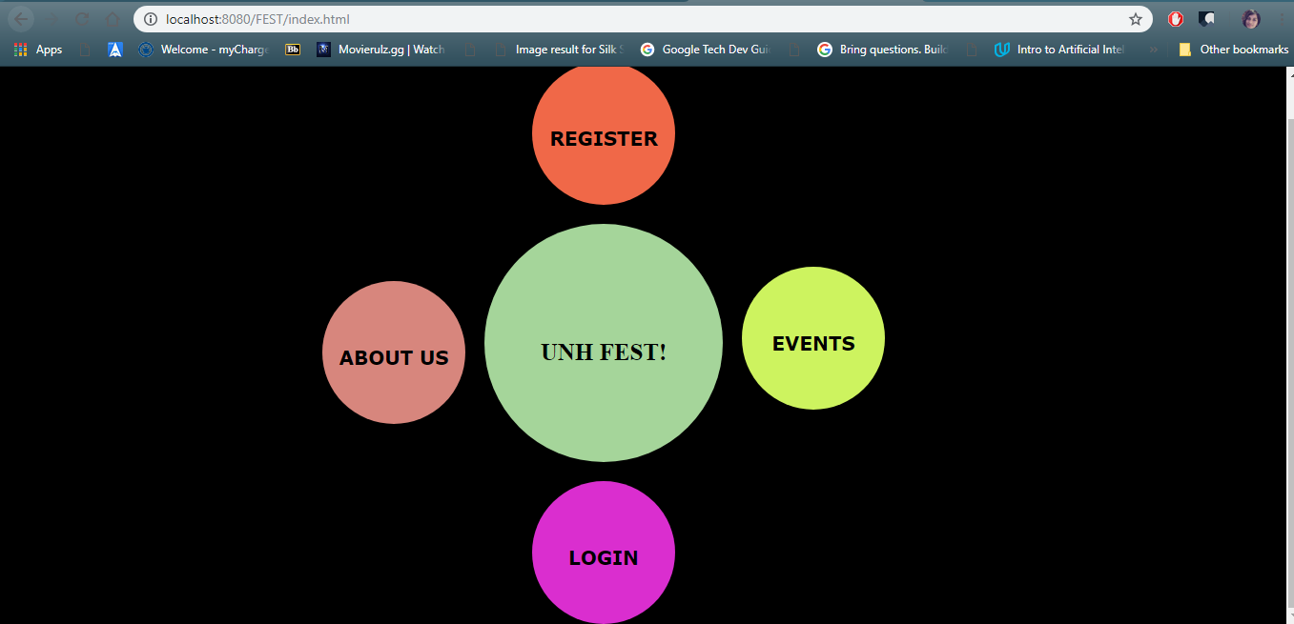

1. Register.jsp

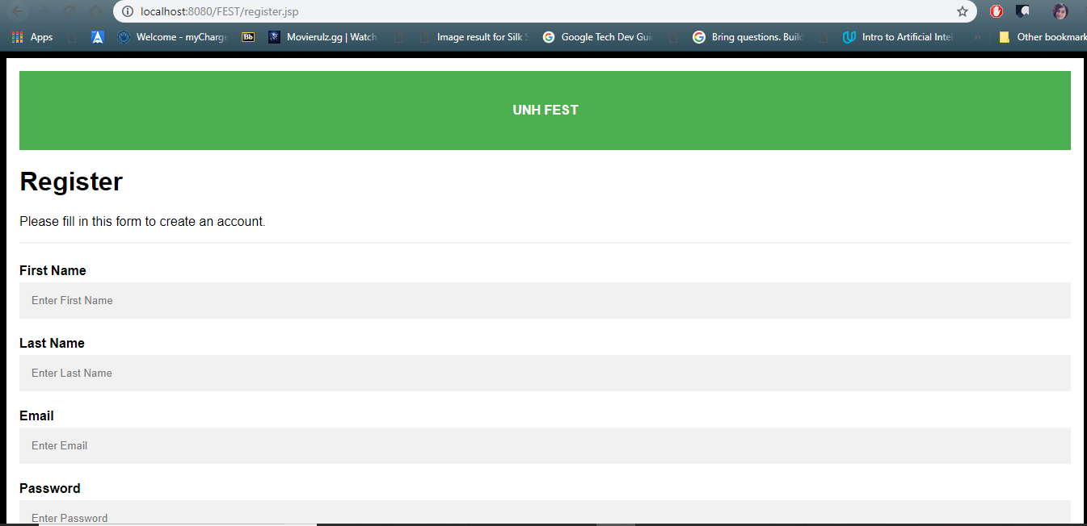

1. About.jsp

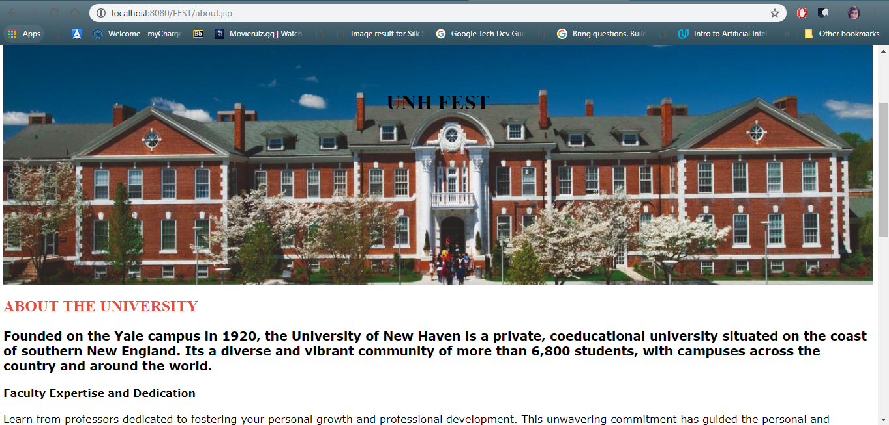

1. Login.jsp

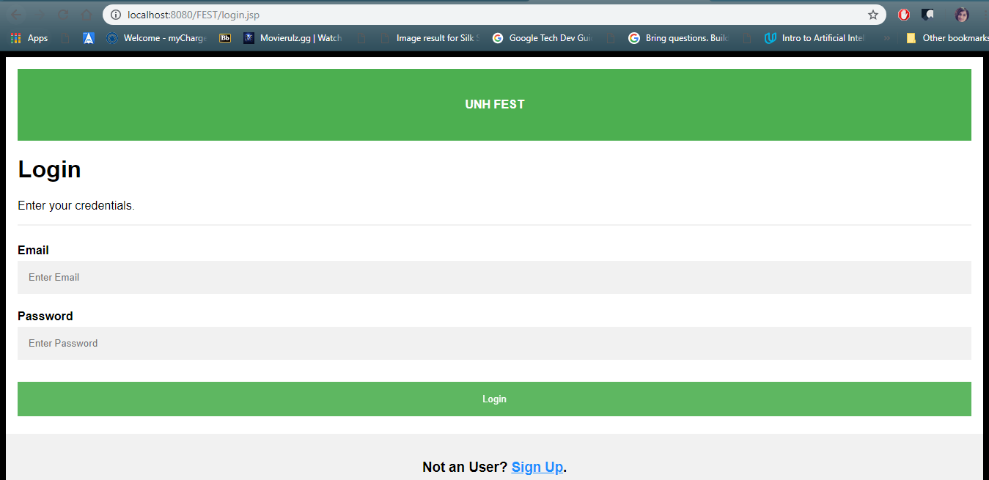

1. Events.jsp

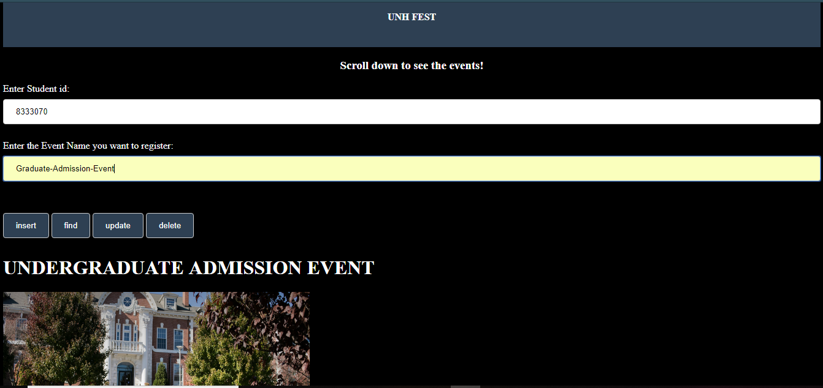

1. display.jsp

